Issues found:

1. Once you get inside a category, there’s no button to get back to the main page.
2. The contact information we had to the main page in previous versions is missing.
3. For example, the Abstract category has 9 images, but on the site we see blank spaces for images 10 to 12.

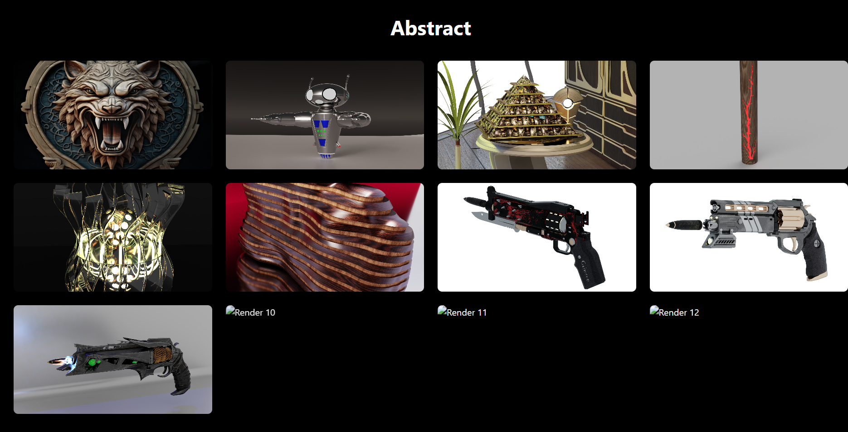

1. On the other side, for example the Architectural category has 15 images, but on the site we can see only 12 with no way of rolling down in the page.

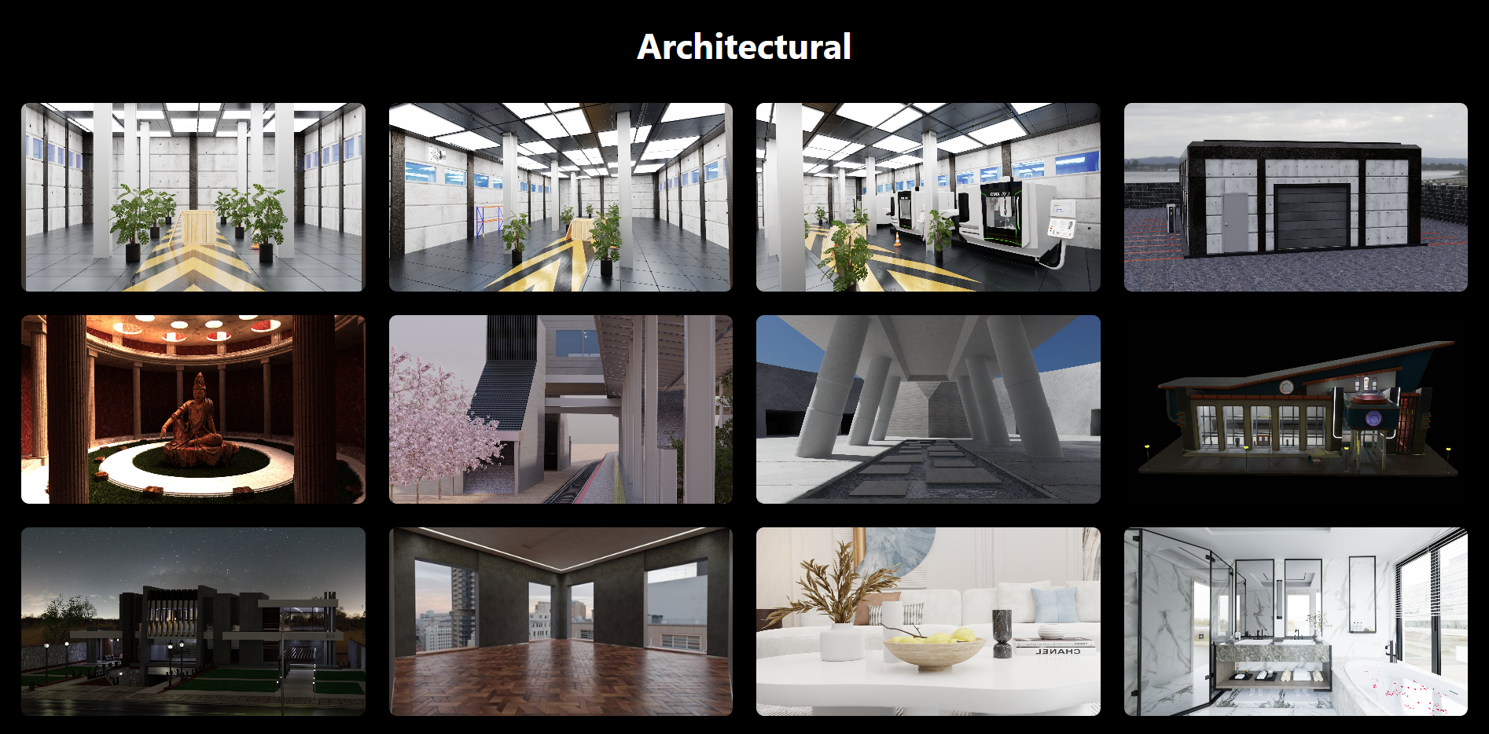

1. When an image is selected inside any category, a new browser tab is opened, which is not correct.
2. Once that image is open there are no way of scrolling through the other images, either is shown any side arrows to click on. The keyboard arrow keys also don’t work. I believe this behavior happens because of point 5.